Test Case: tc001_SPX_Dev5_Crear_Nueva_Linea_Requisicion_Spot_Tipo_Cobro_CC
Step 1 - Enter username and password and click to button Enter : Credentials Entered
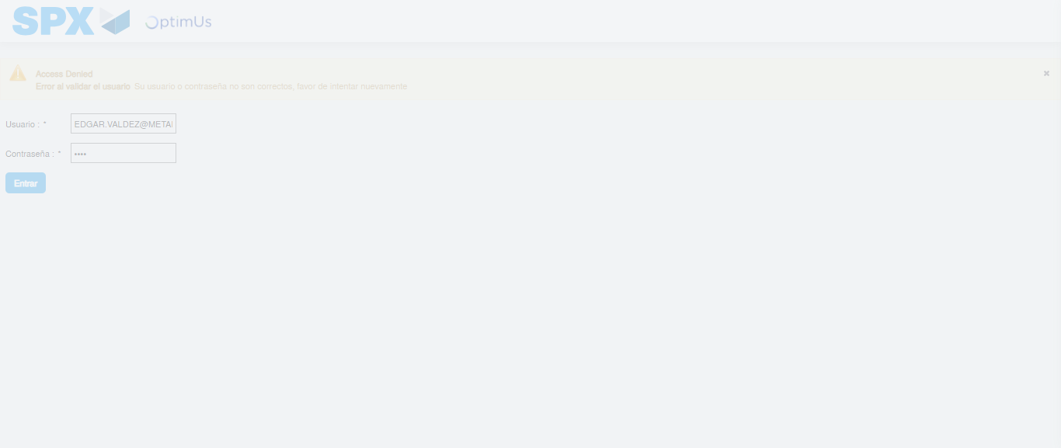Image file-name: QC_Testing-tc001_SPX_Dev5_Crear_Nueva_Linea_Requisicion_Spot_Tipo_Cobro_CC-1781564560325

Step 2 - Select to UEN and Access to Spot Buy Requisitions : UEN Correctly selected and Correct access
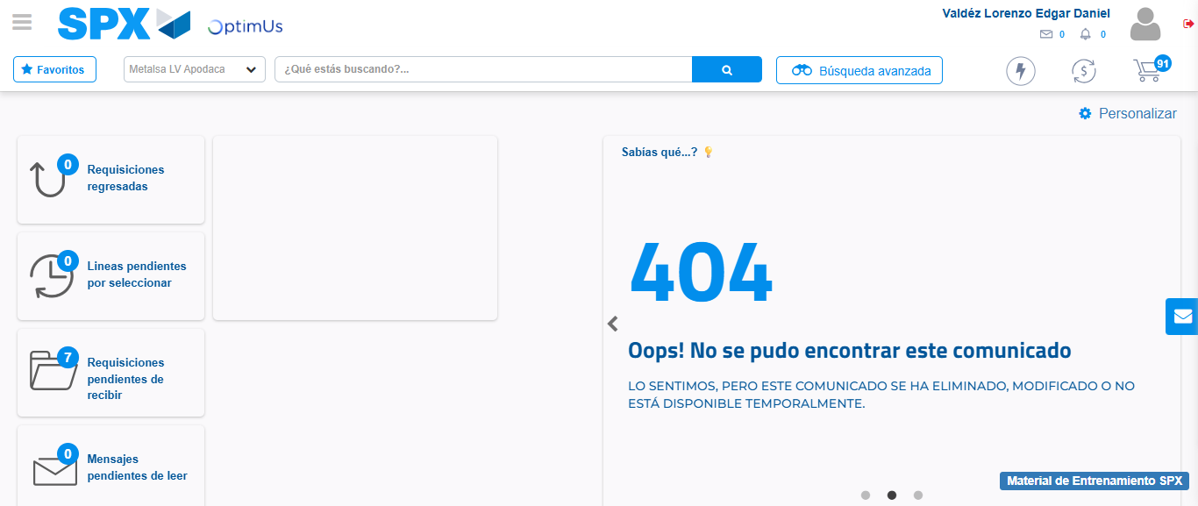Image file-name: QC_Testing-tc001_SPX_Dev5_Crear_Nueva_Linea_Requisicion_Spot_Tipo_Cobro_CC-1781564602020

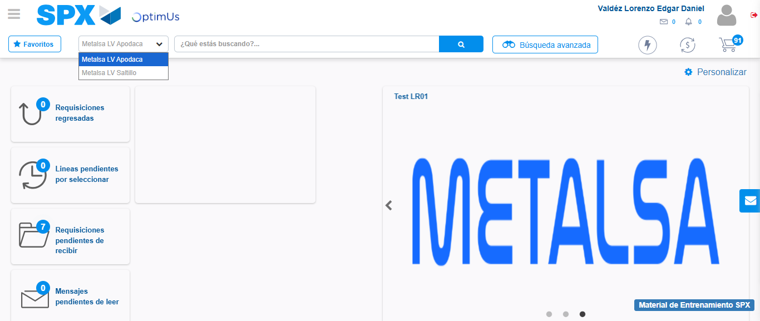Image file-name: QC_Testing-tc001_SPX_Dev5_Crear_Nueva_Linea_Requisicion_Spot_Tipo_Cobro_CC-1781564604591

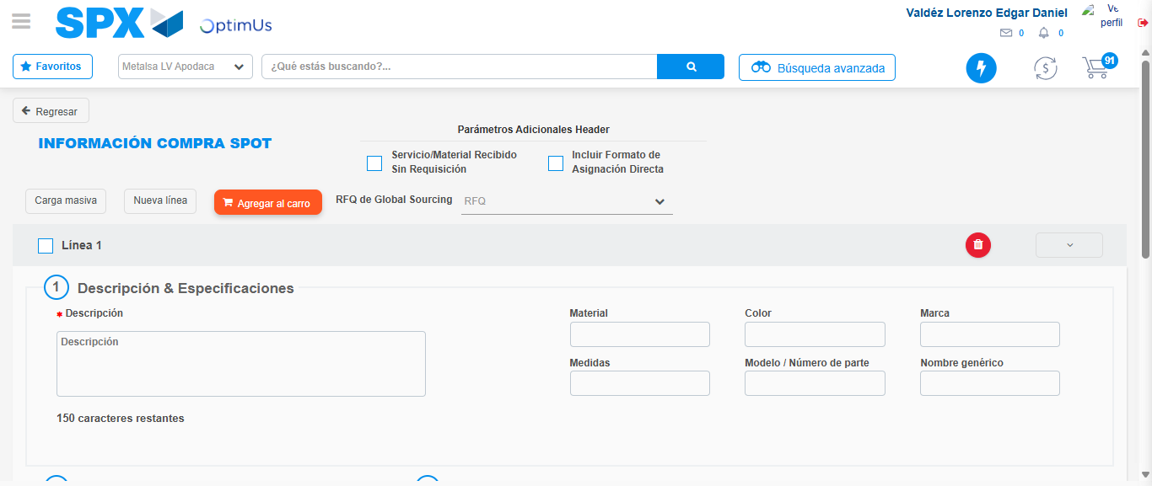Image file-name: QC_Testing-tc001_SPX_Dev5_Crear_Nueva_Linea_Requisicion_Spot_Tipo_Cobro_CC-1781564612929

Step 3 - Data Capture Spot Buy Requisition: Data captured correctly
Image file-name: QC_Testing-tc001_SPX_Dev5_Crear_Nueva_Linea_Requisicion_Spot_Tipo_Cobro_CC-1781564613191

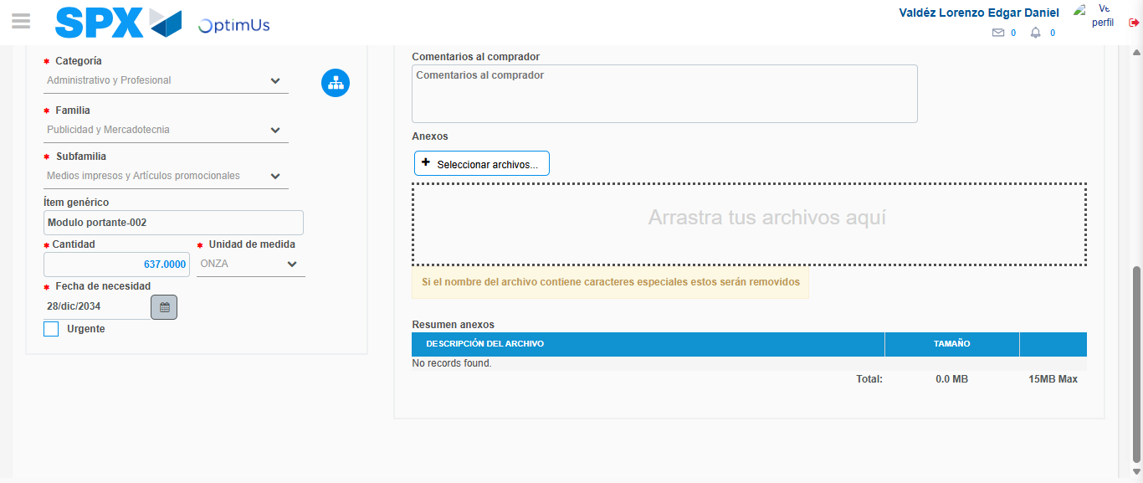Image file-name: QC_Testing-tc001_SPX_Dev5_Crear_Nueva_Linea_Requisicion_Spot_Tipo_Cobro_CC-1781564624493

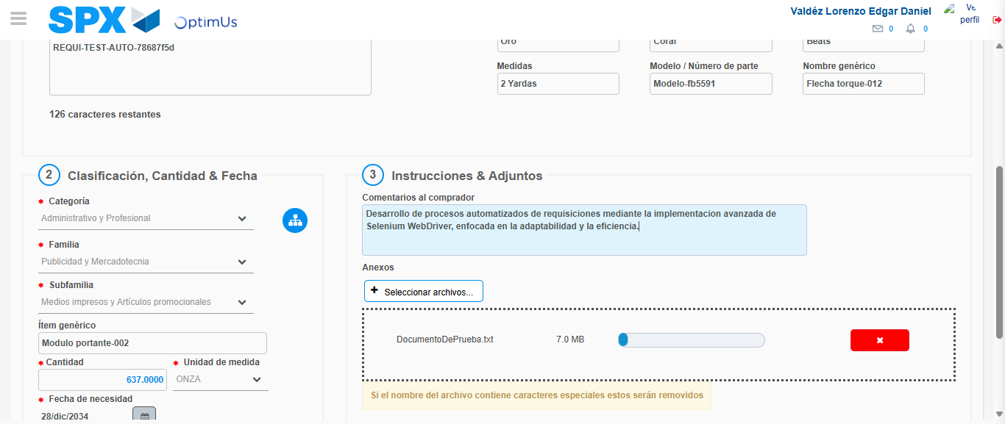Image file-name: QC_Testing-tc001_SPX_Dev5_Crear_Nueva_Linea_Requisicion_Spot_Tipo_Cobro_CC-1781564625339

Step 4 - Add new line and data capture second line: Line add correctly
Image file-name: QC_Testing-tc001_SPX_Dev5_Crear_Nueva_Linea_Requisicion_Spot_Tipo_Cobro_CC-1781564613191

Image file-name: QC_Testing-tc001_SPX_Dev5_Crear_Nueva_Linea_Requisicion_Spot_Tipo_Cobro_CC-1781564624493

Image file-name: QC_Testing-tc001_SPX_Dev5_Crear_Nueva_Linea_Requisicion_Spot_Tipo_Cobro_CC-1781564625339

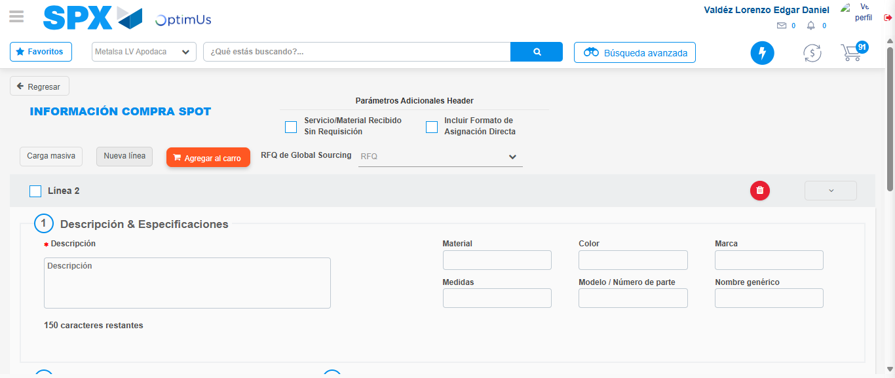Image file-name: QC_Testing-tc001_SPX_Dev5_Crear_Nueva_Linea_Requisicion_Spot_Tipo_Cobro_CC-1781564627743

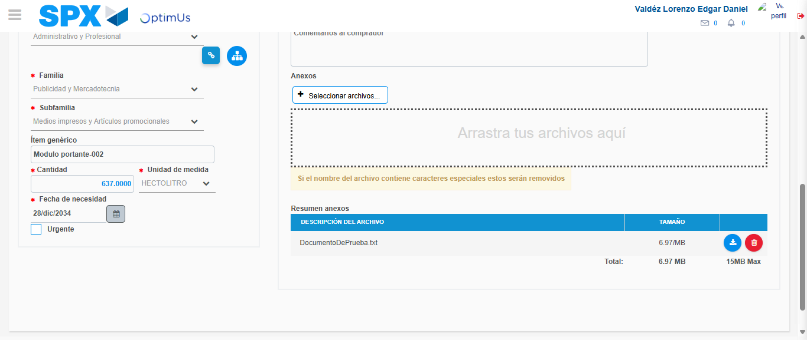Image file-name: QC_Testing-tc001_SPX_Dev5_Crear_Nueva_Linea_Requisicion_Spot_Tipo_Cobro_CC-1781564638510

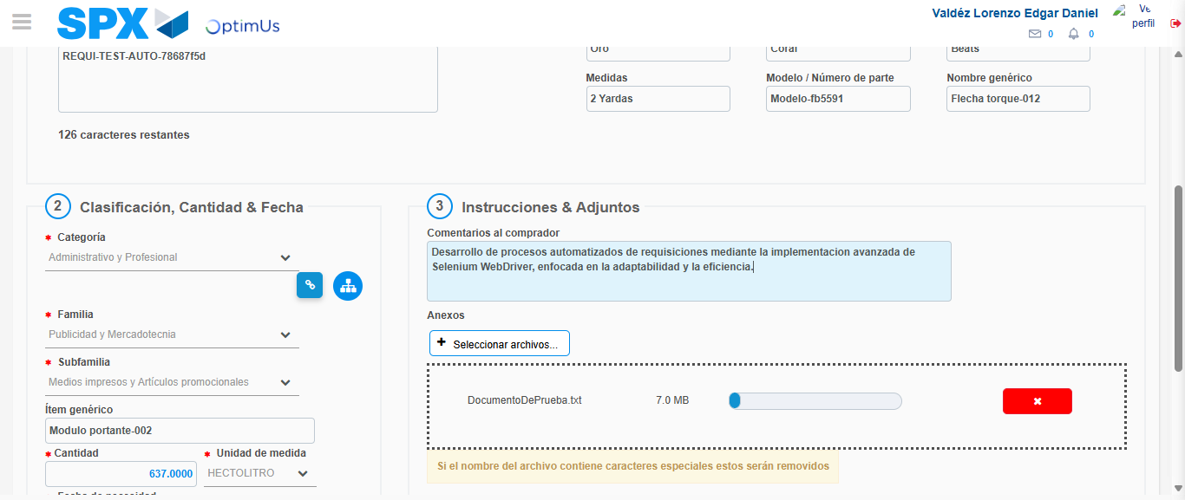Image file-name: QC_Testing-tc001_SPX_Dev5_Crear_Nueva_Linea_Requisicion_Spot_Tipo_Cobro_CC-1781564639295

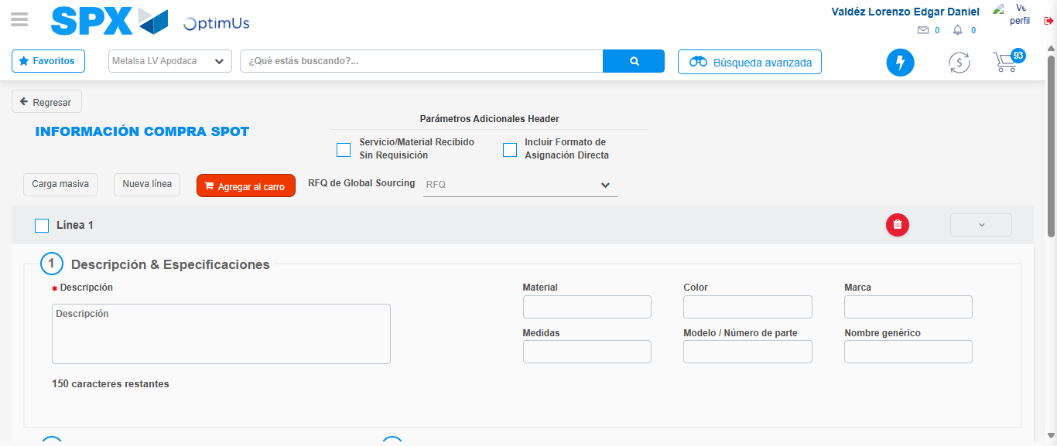Image file-name: QC_Testing-tc001_SPX_Dev5_Crear_Nueva_Linea_Requisicion_Spot_Tipo_Cobro_CC-1781564653559

Step 5 - Select to Requisition: Requisition Correctly selected
Image file-name: QC_Testing-tc001_SPX_Dev5_Crear_Nueva_Linea_Requisicion_Spot_Tipo_Cobro_CC-1781564653751

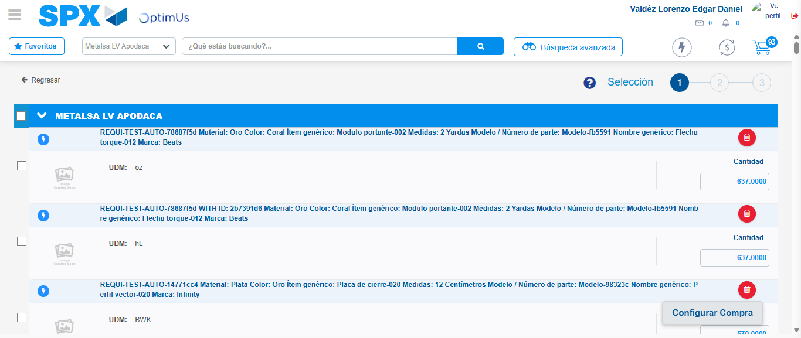Image file-name: QC_Testing-tc001_SPX_Dev5_Crear_Nueva_Linea_Requisicion_Spot_Tipo_Cobro_CC-1781564663713

Image file-name: QC_Testing-tc001_SPX_Dev5_Crear_Nueva_Linea_Requisicion_Spot_Tipo_Cobro_CC-1781564663978

Image file-name: QC_Testing-tc001_SPX_Dev5_Crear_Nueva_Linea_Requisicion_Spot_Tipo_Cobro_CC-1781564664184

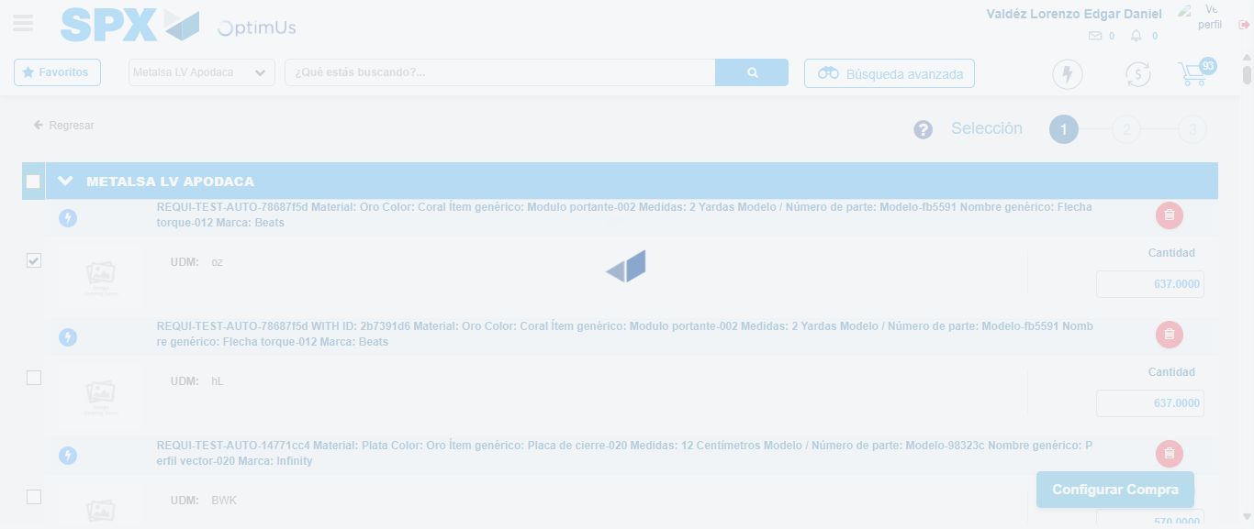Image file-name: QC_Testing-tc001_SPX_Dev5_Crear_Nueva_Linea_Requisicion_Spot_Tipo_Cobro_CC-1781564665070

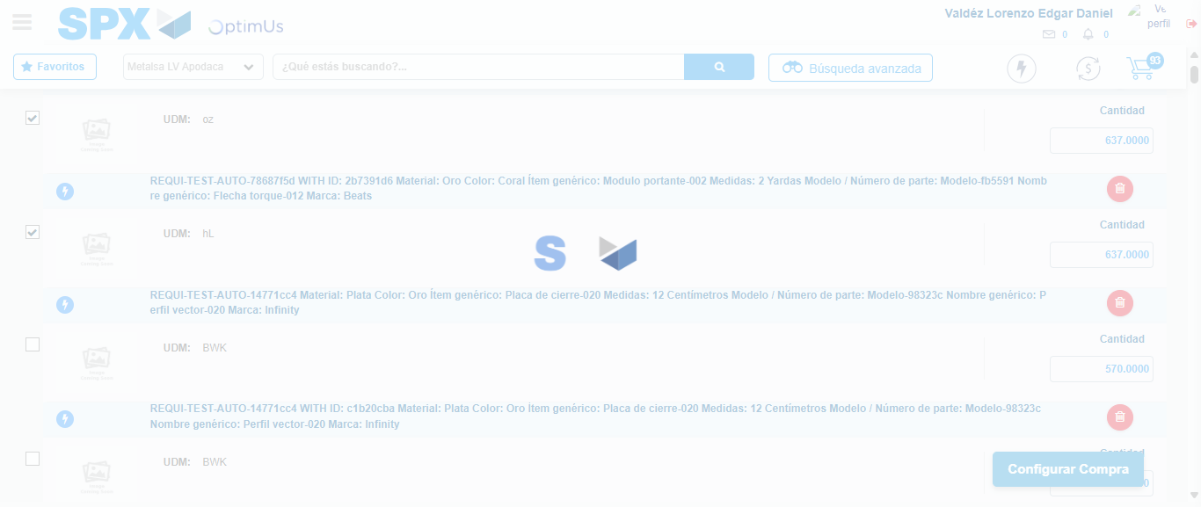Image file-name: QC_Testing-tc001_SPX_Dev5_Crear_Nueva_Linea_Requisicion_Spot_Tipo_Cobro_CC-1781564666513

Step 6 - Select Type Account For Requisition: Type Account Correctly selected
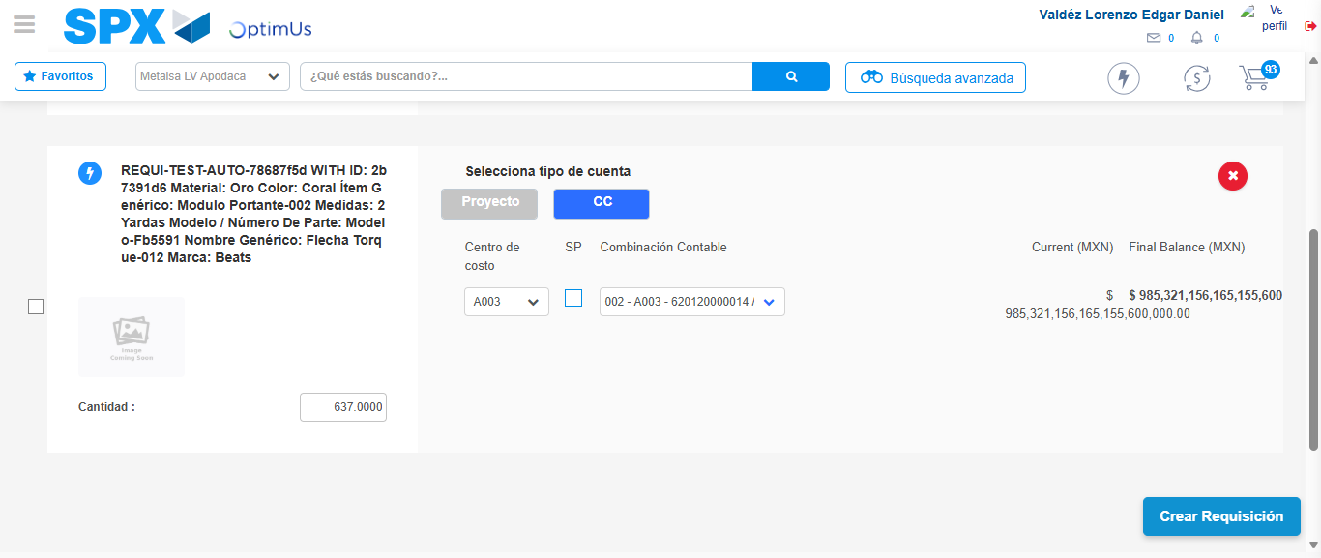Image file-name: QC_Testing-tc001_SPX_Dev5_Crear_Nueva_Linea_Requisicion_Spot_Tipo_Cobro_CC-1781564749522

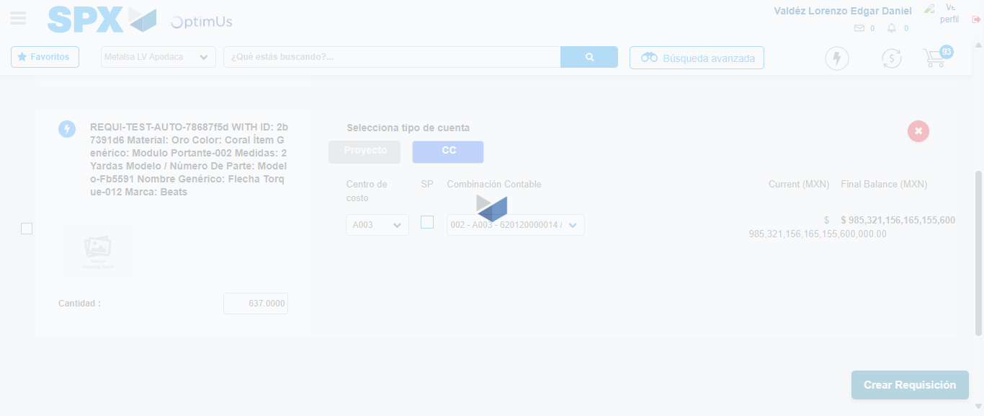Image file-name: QC_Testing-tc001_SPX_Dev5_Crear_Nueva_Linea_Requisicion_Spot_Tipo_Cobro_CC-1781564750015

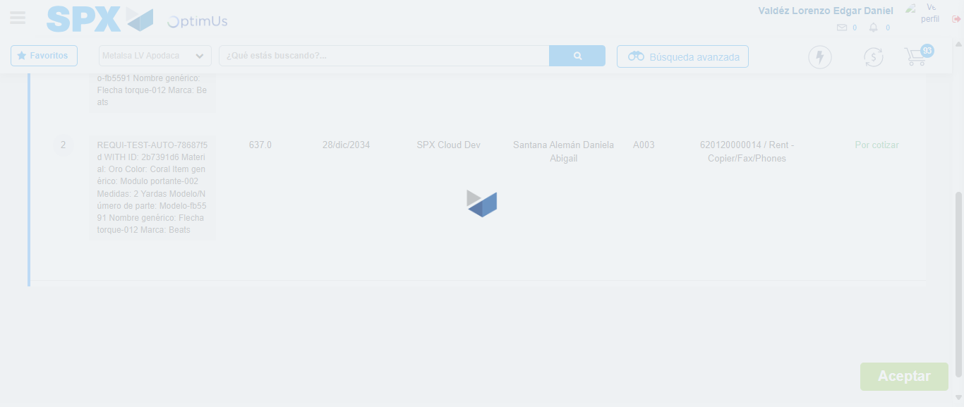Image file-name: QC_Testing-tc001_SPX_Dev5_Crear_Nueva_Linea_Requisicion_Spot_Tipo_Cobro_CC-1781564750255

Step 7 - Accept to Requisition: Requisition Accepted
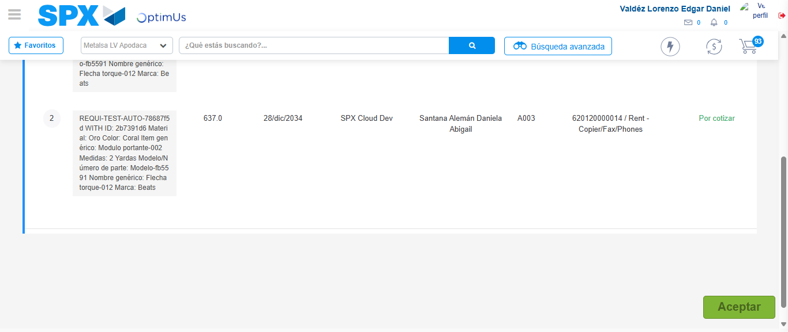Image file-name: QC_Testing-tc001_SPX_Dev5_Crear_Nueva_Linea_Requisicion_Spot_Tipo_Cobro_CC-1781564751048

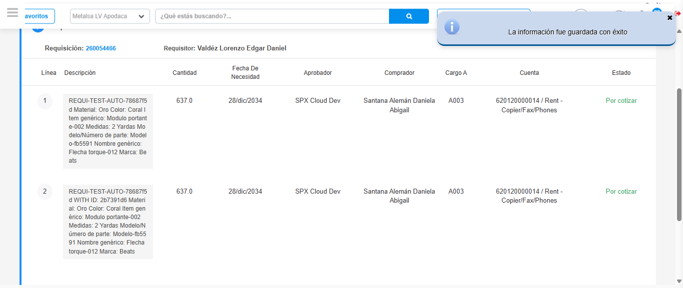Image file-name: QC_Testing-tc001_SPX_Dev5_Crear_Nueva_Linea_Requisicion_Spot_Tipo_Cobro_CC-1781564753539

Step 8 - Return to Main Page SPX : Return to Main Page SPX
Image file-name: QC_Testing-tc001_SPX_Dev5_Crear_Nueva_Linea_Requisicion_Spot_Tipo_Cobro_CC-1781564602020

Image file-name: QC_Testing-tc001_SPX_Dev5_Crear_Nueva_Linea_Requisicion_Spot_Tipo_Cobro_CC-1781564604591

Image file-name: QC_Testing-tc001_SPX_Dev5_Crear_Nueva_Linea_Requisicion_Spot_Tipo_Cobro_CC-1781564612929

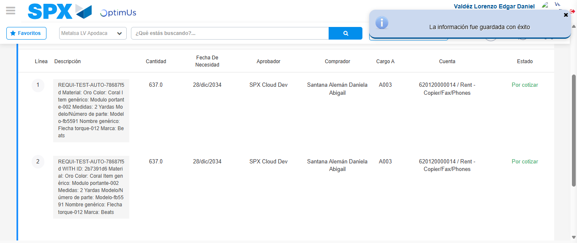Image file-name: QC_Testing-tc001_SPX_Dev5_Crear_Nueva_Linea_Requisicion_Spot_Tipo_Cobro_CC-1781564755785

Image file-name: QC_Testing-tc001_SPX_Dev5_Crear_Nueva_Linea_Requisicion_Spot_Tipo_Cobro_CC-1781564755969

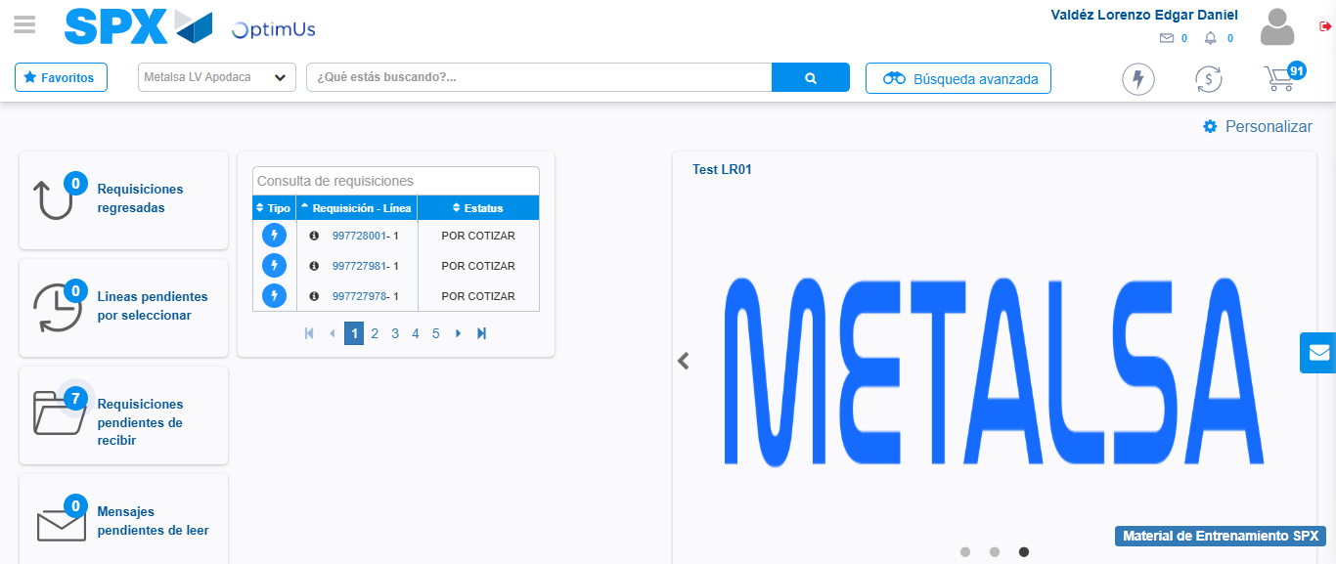Image file-name: QC_Testing-tc001_SPX_Dev5_Crear_Nueva_Linea_Requisicion_Spot_Tipo_Cobro_CC-1781564777111

Step 9 - Log Out : Log Out SPX
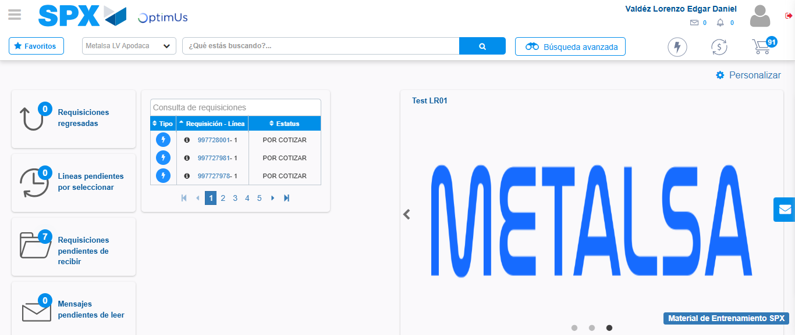Image file-name: QC_Testing-tc001_SPX_Dev5_Crear_Nueva_Linea_Requisicion_Spot_Tipo_Cobro_CC-1781564777345

